**LAPORAN PRAKTIKUM PENGOLAHAN CITRA DIGITAL**

**14. HIGH-PASS FILTERS IN THE FREQUENCY**

**DOMAIN**



**Disusun oleh :**

**Nama : Andhika Rizky Cahya Putra**

**NPM : 2226250071**

**Kelas : IF4A**

**PROGRAM STUDI INFORMATIKA**

**FAKULTAS ILMU KOMPUTER DAN REKAYASA**

**UNIVERSITAS MULTI DATA PALEMBANG**

**2024**

**TUTORIAL : HIGH-PASS FILTERS IN THE FREQUENCY**

**DOMAIN**

**Goal**

The goal of this tutorial is howto implement high-pass filters in the frequency domain.

**Objectives**

* Learn how to generate and apply an ideal high-pass filter.
* Learn how to generate and apply a Gaussian high-pass filter.
* Learn how to generate and apply a Butterworth high-pass filter.

**What You Will Need**

* distmatrix.m
* fddemo.m

**Procedure**

High-pass filters are conceptually the opposite of low-pass filters and can be implemented in MATLAB using techniques that are very similar to the ones described in Tutorial 13. There is, however, a problem when implementing high-pass filters: because a high-pass filter attenuates low frequencies, this means that the zero-frequency term (also known as the DC term) will be set to zero, in turn setting the average value of the image to zero. To compensate for this, we use a technique known as high frequency emphasis filtering, which can be implemented by applying the high-pass filter as we normally would, then multiplying the result (still in the frequency domain) by a constant b, and finally adding an offset constant a.

To begin, let us implement an ideal high-pass filter.

1. Load the eight image, generate, and display its FT.

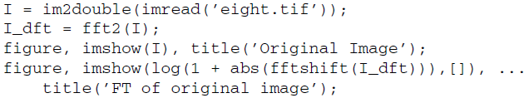

Just as in low-pass filtering, we must generate a distance matrix and use the fftshift function when displaying it.

1. Generate a distance matrix based on the size of the input image.



**Ideal HPF**

1. Create the ideal high-pass filter.

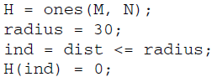

**Question 1** Explain how the previous code generates an ideal high-pass filter. We will now apply the high-frequency emphasis filtering technique with a = b = 1.

|  |
| --- |
|  |

1. Apply high-frequency emphasis filtering to the high-pass filter.



1. Apply the filter to the FT image and display the results.

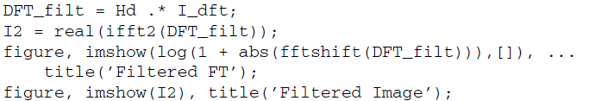

1. Display the filter as an image and as a 3D mesh in separate figures.



**Question 2** When displaying the filter as an image, why must we scale the output for display purposes?

|  |
| --- |
|  |

**Question 3** How does the filtered image compare to the original image?

|  |
| --- |
|  |

We can use the frequency-domain demo (fddemo) to experiment with different values for the radius of the filter. Note that to use fddemo, the M-file distmatrix.m must be in the same directory.

1. Start the frequency-domain demo.



1. From the filter pull-down menu, select Ideal High Pass.

Notice that the filter profile shows a magenta circle, indicating the current cut off value for the filter. The cutoff value is displayed below the profile figure. To change the cutoff value, drag the magenta circle in or out. You will notice that as you drag the circle, the displayed cutoff value changes.

1. Drag the cutoff circle so that the cutoff value is 30 to create the same filtered image as we did above.
2. Change the cutoff value to 10.

**Question 4** How does the new image compare to the original image?

|  |
| --- |
|  |

**Question 5** How does the output compare between using a cutoff value of 30

and 10?

|  |
| --- |
|  |

**Question 6** What happens to the filtered image as we increase the cutoff value (beyond 30) with respect to the original image?

|  |
| --- |
|  |

1. Close any open figures or demos.

**Gaussian HPF**

We can implement the Gaussian high-pass filter using the existing distance matrix (stored in variable dist).

1. Generate a Gaussian high-pass filter.



1. Apply high-frequency emphasis filtering to the high-pass filter and display the filter.

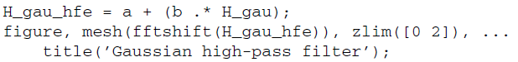

We can now apply the filter to the image.

1. Apply the filter and display the results.

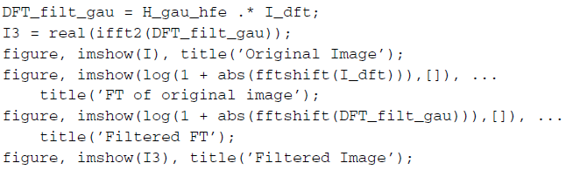

**Question 7** How does the Gaussian-filtered image compare to the ideal-filtered image?

|  |
| --- |
|  |

We can see the effects of the value chosen for σ (sigma) by using the frequency domain demo.

1. Start the frequency-domain demo.



1. From the filter pull-down menu, select Gaussian High Pass.

Notice that the default value for the standard deviation (σ) is 30, so the filtered image should be equal to what we have implemented above. Let us now change this value to see its effect on both the filter and the resulting image.

1. Change the standard deviation to 10.

**Question 8** What happened to the filter?

|  |
| --- |
|  |

**Question 9** How was the filtered image affected?

|  |
| --- |
|  |

**Question 10** In general, how does the filter change when the standard deviation of the filter is increased or decreased?

|  |
| --- |
|  |

1. Close any open figures or demos.

**Butterworth HPF**

To implement the Butterworth high-pass filter, we can again use the existing distance matrix (stored in variable dist).

1. Generate a Butterworth high-pass filter.



1. Apply high-frequency emphasis filtering to the high-pass filter and display the resulting filter.

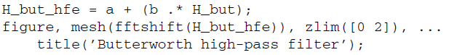

1. Apply the filter to the input image and display the results.

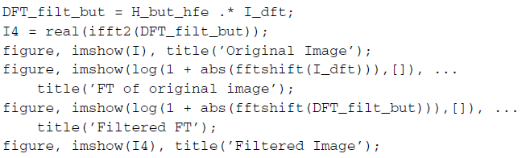

In the last portion of this tutorial, we will further explore Butterworth high-pass filters using the fddemo.

1. Load fddemo.



1. From the filter pull-down menu, select Butterworth High Pass.

This filter has two parameters: cutoff value and order. The cutoff value can be

adjusted simply by dragging the magenta circle. To change the order of the filter, type a new value and press Update.

**Question 11** How does the order parameter change the shape of the filter?

|  |
| --- |
|  |

**Question 12** For large order values (such as 10), the Butterworth begins to take the shape of what other high-pass filters take?

|  |
| --- |
|  |